Education Extravaganza 2022
EdEx22
GCSE Science Trilogy
Do Now:
1 | What bonding occurs between metals and non-metals?
2 | What is the chemical formula of methane?
3 | What does DNA stand for?
4 | What is the constant speed equation?
5 | What is the chemical formula for an alkane with 117 carbon atoms?
6 | What is the atomic number of the largest predicted element?

Lesson 1 (Physics): The Atom and Advanced Analysis Techniques

Topics: 5.1.1.4, 5.1.1.5, 5.1.1.7, 6.4.1.1, 6.4.1.2, 6.6.2.1, 6.6.2.2, 6.6.2.3

Class Discussion: Atomic Structure Recap

- The atom has two parts: electron shells or energy levels and the nucleus.
- The electron shells or energy levels form “rings” around the dense nucleus and fill up with electrons in the order of 2,8,8.
- The nucleus contains protons and neutrons in a tight arrangement.
- Protons carry a +1 charge and have a mass of 1, electrons carry a charge of -1 and have a negligible (close to 0) mass and neutrons have a neutral (0) charge and a mass of 1.

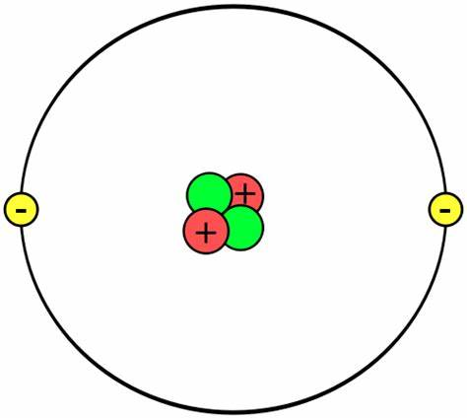

A helium atom contains 2 protons, 2 electrons and 2 neutrons.

Key Knowledge: Atomic Structure Extended

- The electron has a mass of about $\frac{1}{1840}$.
- If the nucleus of a hydrogen atom is the size of a tennis ball, the atom’s diameter would be 8 km.
- Neutrons are in the nucleus of an atom to stop the protons from repelling each other, causing the atom to fall apart.

Key Knowledge: Flame Test for Metal Ions

- The flame test is a chemical analysis technique in which a metal ion is held over a flame.
- When the element burns it emits a specific colour of light. For example, lithium burns with a red colour.
- However, for some elements, it is difficult to distinguish one from another. For example, both indium and selenium burn with a blue colour.
- Furthermore, not all elements produce a change in colour, only metal ions can be tested, and some compounds are unsafe to test. For example, lithium chloride produces chlorine gas when burnt.
- The flame test produces qualitative results as a colour is difficult to accurately measure.

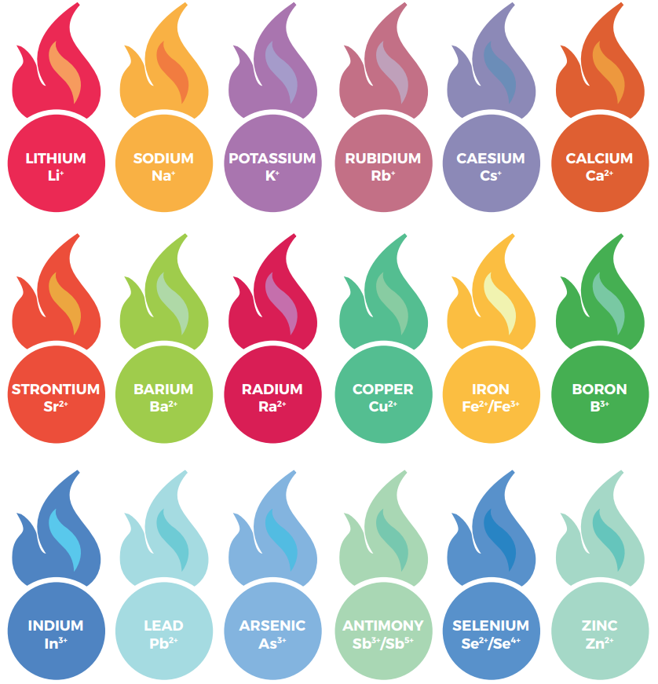

Common metal ion flame test results.
Progress Check

Match the metal ion with its flame colour.

Green
Sodium
Light Blue
Lithium

Light Green
Boron
Yellow
Selenium

Red
Barium

Key Knowledge: Spectroscopy

- Spectroscopy is a chemical analysis technique in which light is split by a prism or grating and passed through a sample.
- This uses the same principle as the flame test, where each element produces its own colour or wavelength of light.
- A prism or grating is used to split the light into its component colours before being passed through a sample – a technique first developed by Isaac Newton.
- Spectroscopy produces a pattern of different wavelengths of light called a spectrum – this is unique to each element.
- Each coloured line represents a different wavelength of light on the electromagnetic spectrum.
- Violet has the shortest wavelength and red has the longest.
- Spectroscopy produces quantitative results as a wavelength can be measured.

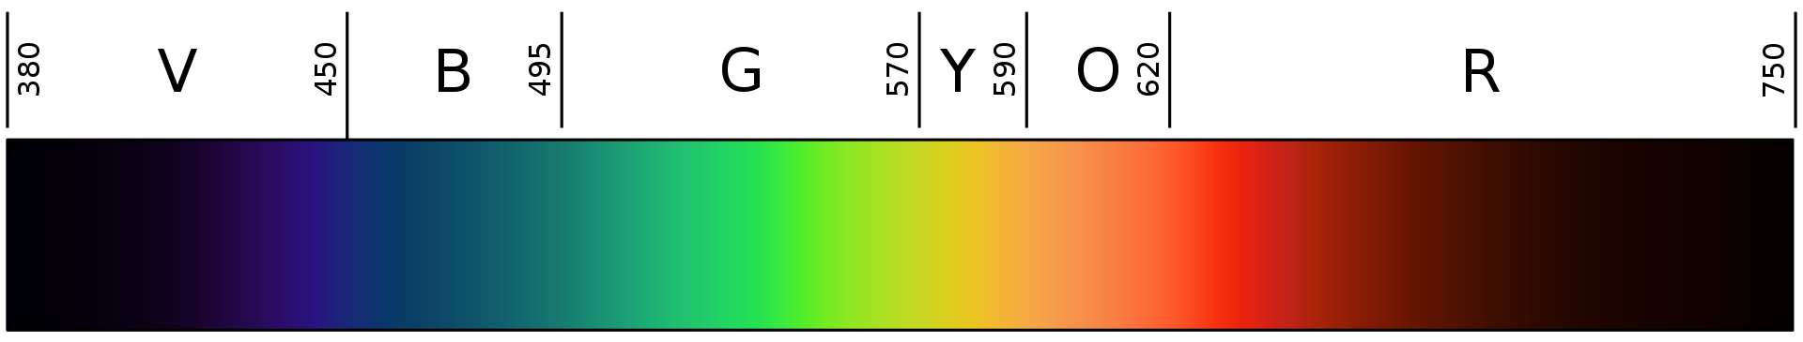

The visible spectrum – the numbers correspond to the wavelength of light in nanometres (nm).

Mastery Questions

- What can split white light into its component colours? [1 mark]
- What is the longest wavelength of visible light? [1 mark]
- What are some of the problems with the flame test? [3 marks]
- Why is spectroscopy more accurate than the flame test? [5 marks]

Key Knowledge: The Emission Spectrum

- Spectroscopy and the flame test both use the wavelength of light emitted from an element to identify it.
- As mentioned previously, every element produces a unique spectrum of light, this is referred to as the emission spectrum (plural spectra).
- The emission spectrum is produced when light interacts with the element, or it is combusted.

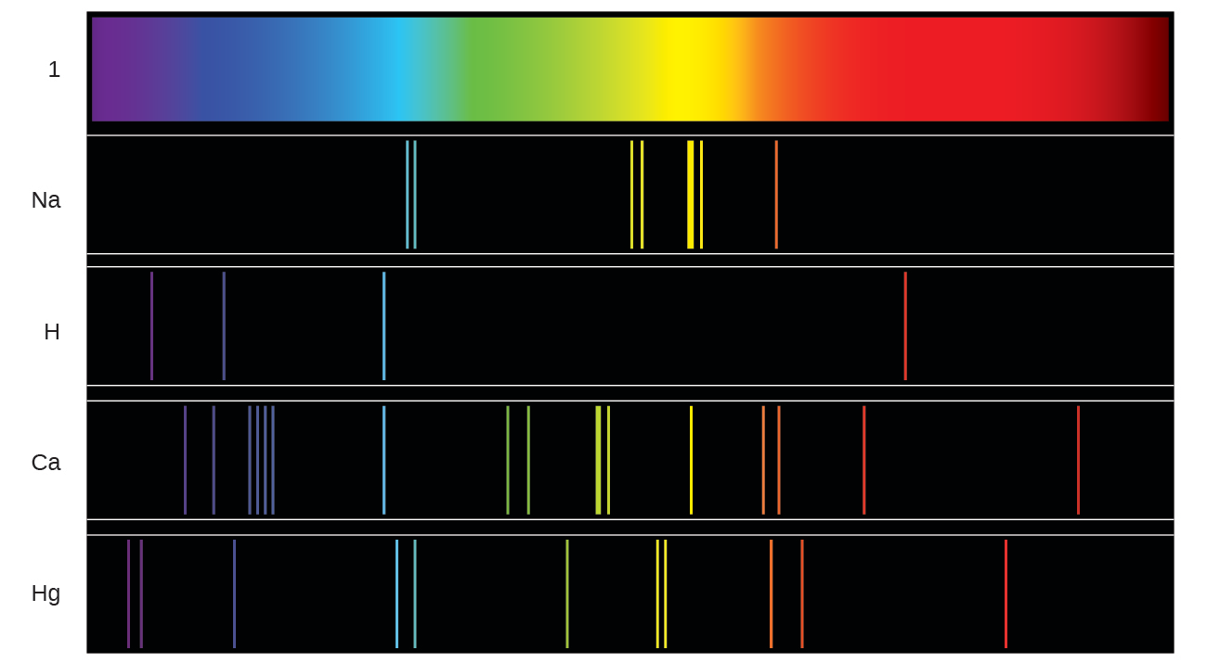

The emission spectrum of various elements.

Key Knowledge: Electron Excitation

- Different elements have different emission spectra. This is due to their unique electron arrangement.
- When light is directed onto an atom, the electrons are excited. Excitement is the technical term for when electrons gain energy.
- Electrons gain energy because light contains energy which is absorbed by electrons.
- When electrons are excited, they move up energy levels because they have more energy.
- However, electrons will eventually emit this energy and move back to their original energy level.
- When this happens, the energy is emitted as an electromagnetic wave (light).
- This emitted light is what causes emission spectra.
- The emitted light is unique as energy levels have different energy values, so each of the possible electron transitions within an atom will produce different energy.
- An electron’s initial position within an atom is known as the ground state and its new position is called the excited state.

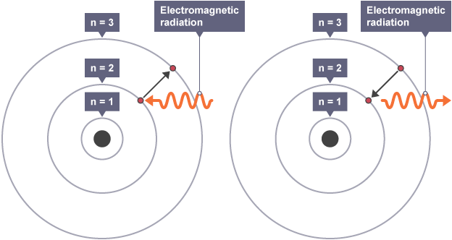

An electron absorbs and emits electromagnetic radiation.

Deliberate Practice

Q1.

(a) The visible light spectrum has a range of frequencies.

Figure 1 shows that the frequency increases from red light to violet light.

Figure 1

Increasing frequency

Red | Green | Violet

Use the correct answers from the box to complete the sentence.

decreases | stays the same | increases

As the frequency of the light waves increases, the wavelength

of the light waves ______________________________ and

the energy of the light waves ______________________________ .

(2)

(b) Bottled beer will spoil if the intensity of the light passing through the glass bottle into the beer is too high.

Figure 3 shows the intensity of the light that is transmitted through three different pieces of glass.

Figure 3

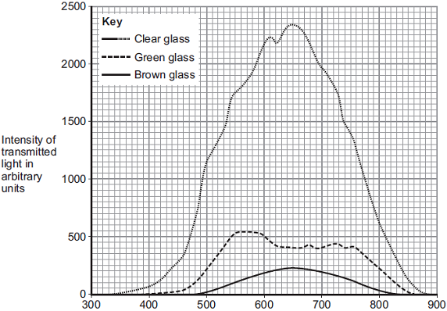
Wavelength × 10^{– 9} in metres

(i) The pieces of glass all had the same thickness.

Suggest why.

______________________________________________________

______________________________________________________

(1)

(ii) Bottles made of brown glass are suitable for storing beer.

Suggest why.

_______________________________________________________

_______________________________________________________

(1)

(Total 4 marks)

Q2.

Figure 1 shows two models of the atom.

Figure 1
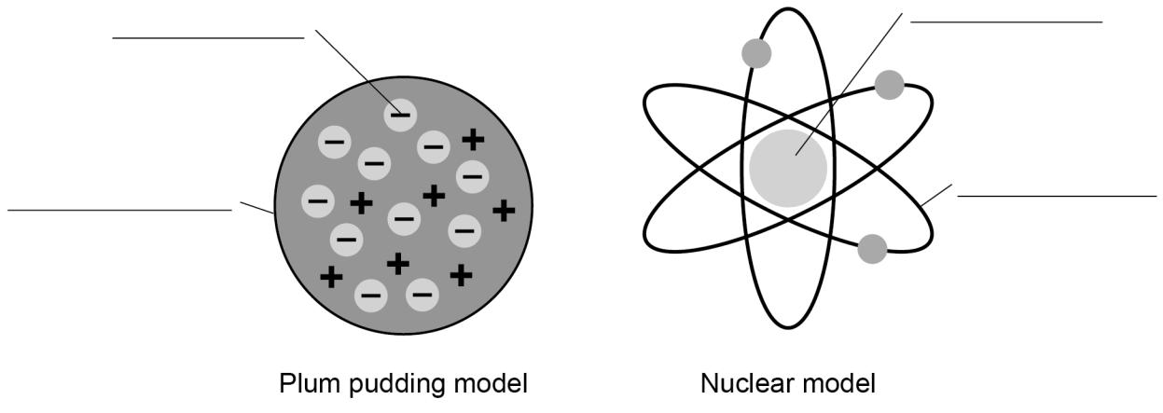

Write the labels on Figure 1

Choose the answers from the box.
(Total 4 marks)

atom |  | electron |  | nucleus
neutron |  | orbit |  | proton
Q3.
Some street lamps contain sodium.
Figure 5 shows two isotopes of sodium.
Figure 5
²³₁₁ Na ²⁴₁₁ Na
(a) What are isotopes?

________________________________________________________

________________________________________________________

________________________________________________________

________________________________________________________

(2)

(b) How many protons and neutrons are in a nucleus of ²³₁₁ Na?
Number of protons = ____________________

Number of neutrons = ____________________

(2)

(c) The sodium atoms emit light.

What would cause light to be emitted from a sodium atom?

Tick one box.

Electrons being emitted from the nucleus.

Electrons falling to a lower energy level.

Electrons leaving the atom when it is ionised.

Electrons moving to a higher energy level.

(1)

(Total 5 marks)

Do Now:
1 | How many chambers does the heart have?
2 | What is Avogadro’s constant?
3 | What protein naturally seals cuts, creating scabs?
4 | What form of current is distributed through the UK mains power grid?
5 | What is the largest particle accelerator?
6 | What is the category of particle that pions are a part of?

Lesson 2 (Chemistry): The Periodic Table

Topics: 5.1.1.1, 5.1.1.4, 5.1.1.5, 5.1.1.7, 5.1.2.1, 5.1.2.2, 5.1.2.3, 5.1.2.4, 5.1.2.5, 5.1.2.6, 5.4.1.2

Class Discussion: The Periodic Table Structure

- The periodic table is a chart of all the chemical elements.
- The table is split into rows called periods and columns called groups.
- There are 7 periods and 8 groups (technically 18).
- There are metals on the left and nonmetals on the right.
- Between the metals and nonmetals there are the metalloids which have properties of both.
- Some groups have names: Group 1 is the Alkali Metals, Group 7 is the Halogens and Group 0 is the Noble Gases.

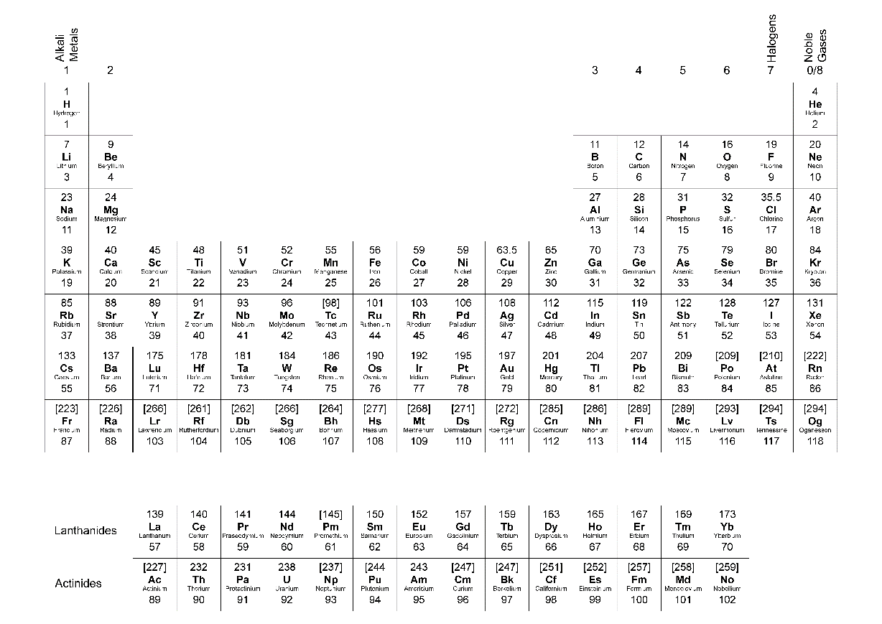

The Periodic Table.
Key Knowledge: The Development of the Periodic Table

- The modern periodic table was first created by Dmitri Mendeleev in 1869.
- However, this does not mean that it was the first…
- In 1806, John Dalton created the first periodic table.

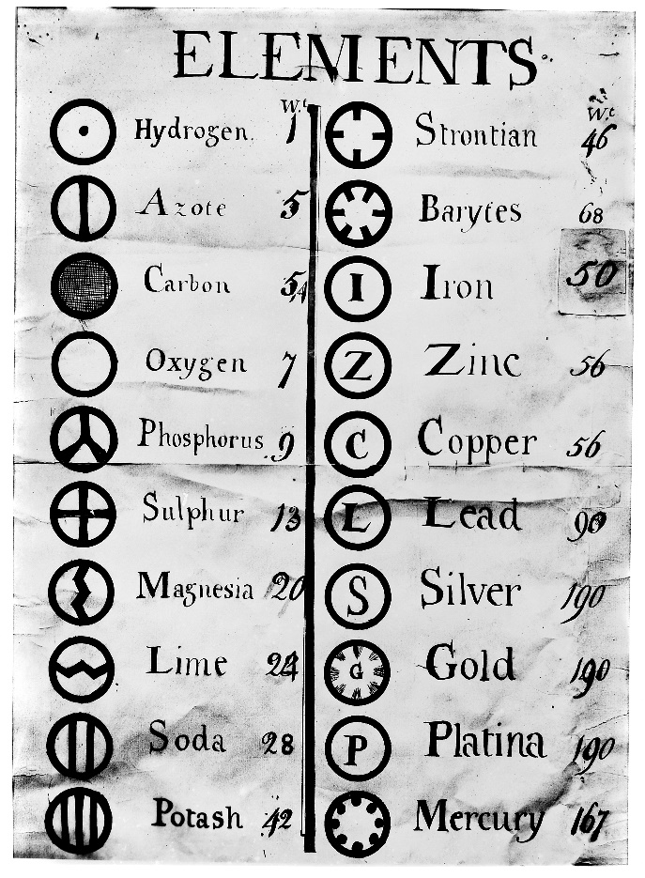

Dalton’s 1806 table.

- Then, Johann Wolfgang Döbereiner discovered the law of triads in 18229. Triads are groups of three elements that have similar properties, much like the modern periodic table groups.
- In total, five triads were discovered: lithium, sodium and potassium; calcium, strontium and barium; chlorine, bromine and iodine; sulfur, selenium and tellurium; and iron, cobalt and nickel.
- The law of triads stated that in each triad, the smallest and largest element’s masses should mean average to the middle element.
- The next development was a much larger table by Alexandre Emile Béguyer de Chancourtois in 1862.
- Then came John Newlands, who based his table on his new law of octaves, in 1864.
- There were several problems with Newlands’ table: due to a lack of known elements, mistakes were often found as elements were placed in inappropriate groups to follow the rule of increasing atomic weight and the rule of octaves strictly.
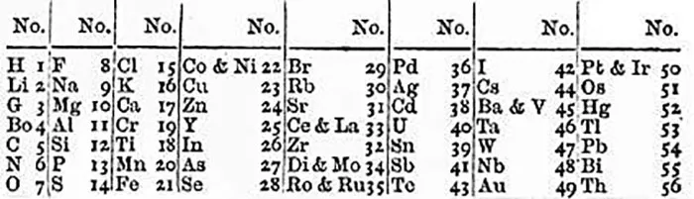

Newlands’ 1864 table.

- Finally, in 1869 Dmitri Mendeleev published his first table building upon the past ideas of Dalton and Newlands (Chancourtois’ did not prove very popular) but ensuring to leave gaps for undiscovered elements where others did not fit with trends.

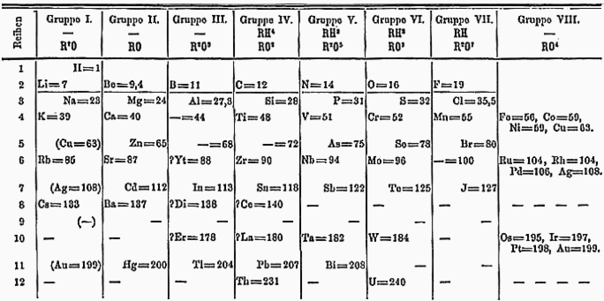

A newer revision of Mendeleev’s table published in 1871.

- In later years, many new elements were discovered that slotted into the table – such as gallium. However, a few were discovered which did not fit. These became known as the Noble Gases and were placed in Group 0.

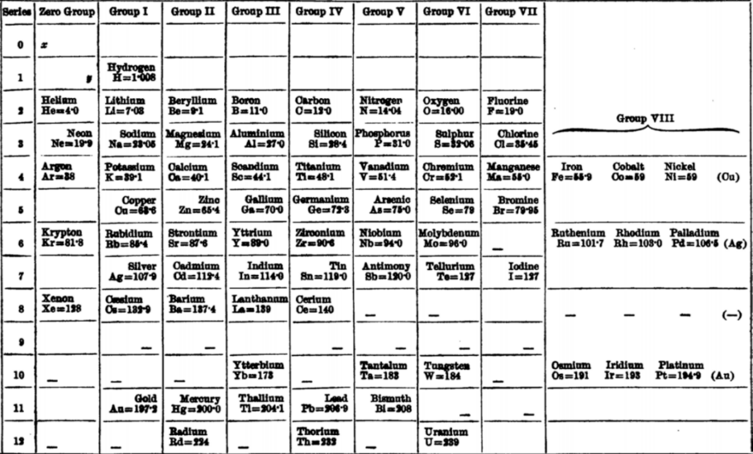

A 1904 version of Mendeleev’s table showing the noble gases in group 0.
Progress Check

Write which years the below scientists created a periodic table.

John Newlands
Dmitri Mendeleev
John Dalton

Key Knowledge: Reading the Periodic Table

- The periodic table is arranged in order of atomic number (how many protons/electrons there are)
- The period number is the number of electron shells an atom of that element has and the group number is how many electrons are in the outer shell.
- Using this information, you can draw a diagram of an atom.
- You can quickly find elements if you know their atomic number.
- Simply identify which period the element is in using the below diagram.

Atomic Number Range | Period | Elements in Period
0-2 | 1 | 2
2-10 | 2 | 8
11-18 | 3 | 8
19-36 | 4 | 18
37-54 | 5 | 18
55-86 | 6 | 32
87-118 | 7 | 32

Element period diagram.

- To find what ion an element will form, you can use the group number. Elements in Group 1 will form +1 ions as it loses an electron. This rule holds true until Group 4 – where atoms behave differently. Elements in Group 5 will form -3 ions – for all future groups add 1 to the number.
- To find what elements are diatomic – form molecules of two atoms. Use the acronym BrINClHOF or the mnemonic “Have (Hydrogen) No (Nitrogen) Fear (Fluorine) Of (Oxygen) Ice (Iodine) Cold (Chlorine) Beer (Bromine)” which lists all the diatomic elements.

Mastery Questions

- Who created the modern periodic table? [1 mark]
- How are the elements of a period arranged in the modern periodic table, from left to right? [1 mark]
- What period is rhodium – atomic number 45 – in? [1 mark]
- What are three differences between John Newland’s table and the modern version? [3 marks]

Key Knowledge: The Reactivity Series

- The reactivity series lists elements in order of their reactivity – starting with the most reactive.
- The mnemonic “Please Stop Calling Me A Careless Zebra Instead Try Learning How Copper Saves Gold Pencils” is helpful when remembering the reactivity series.

Potassium
Increasing Reactivity
Sodium
Calcium
Magnesium
Aluminium
Carbon
Zinc
Iron
Tin
Lead
Hydrogen
Copper
Silver
Gold
Platinum

The Reactivity Series.

Deliberate Practice

Q1.
Some theories suggest that the Earth’s early atmosphere was the same as Mars’ atmosphere today.
The table below shows the percentage of four gases in the atmosphere of Mars today and the atmosphere of Earth today.

Gases | The atmosphere of
Gases | Mars today | Earth today
Carbon dioxide | 95.00% | 0.04%
Nitrogen | 3.50% | 78.00%
Argon | 1.00% | 0.96%
Oxygen | 0.50% | 21.00%
(a) Which one of the gases in the table is a noble gas?
___________________________________________________________
(1)
(b) Draw a ring around the correct answer to complete each sentence.

(i) | Noble gases are in Group | 0  1  7
(1)

(ii) | Noble gases are | slightly reactive.  unreactive.  very reactive.
(1)
(Total 3 marks)
Q2.
Fossil fuels contain carbon and hydrogen.
(a) (i) Use the Chemistry Data Sheet to help you to answer this question.
Complete the figure below to show the electronic structure of a carbon atom.
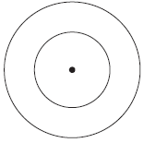
(1)
(ii) Complete the word equation for the oxidation of hydrogen.
hydrogen + oxygen ______________________
(1)
(Total 2 marks)
Q3.
Where copper ore has been mined there are areas of land that contain very low percentages of copper compounds.
One way to extract the copper is to grow plants on the land.
The plants absorb copper compounds through their roots.
The plants are burned to produce copper oxide.
The copper oxide produced from plants can be reacted to produce copper or copper sulfate solution, as shown in Figure 1.
Figure 1
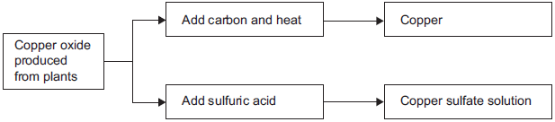
(a) Complete and balance the chemical equation for the reaction of copper oxide with carbon.
____CuO + C __________________ + CO₂
(2)
(b) Copper is produced from copper sulfate solution by displacement using scrap iron or by electrolysis.
(i) Use the Chemistry Data Sheet to help you to answer this question.
Give two reasons why scrap iron is used to displace copper.
_______________________________________________________
_______________________________________________________
_______________________________________________________
_______________________________________________________
(2)
(ii) Figure 2 shows the electrolysis of copper sulfate solution.
Figure 2
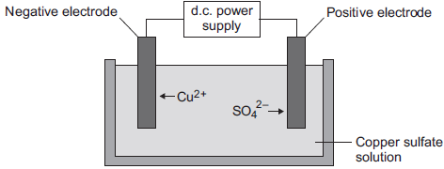
Describe what happens to the copper ions during electrolysis.
_______________________________________________________
_______________________________________________________
_______________________________________________________
_______________________________________________________
(2)
(Total 6 marks)

Periodic Table Development Timeline

Watch the documentary and use information from the lesson to fill-in the years on the timeline of the development of the periodic table. Some have been done for you.

Ancient: The first elements are discovered.

1789: Antoine-Laurent de Lavoisier complies the first list of the elements. At the time only
33 were known.

1806:

1828: Jöns Jacob Berzelius compiles a list of relative atomic weights, where oxygen was set
to 100. He also invented chemical symbols.

1829:

1862:

1864:

1868: Julius Lothar Meyer complies his first periodic table, with features similar to
Mendeleev’s – it wasn’t published until 1870.

1869:

1875: Gallium is discovered by Paul Émile Lecoq de Boisbaudran in Paris – it proves
Mendeleev’s predictions about the element made using his table.

1894: William Ramsay discovers the noble gases – these would later be added to the table as
a new group.

1904:

1913: Henry Moseley discovers atomic number – the number now used to arrange the
elements in the periodic table.

1944: Glenn Seaborg proposes the Lanthanide and Actinide series on the periodic table.

